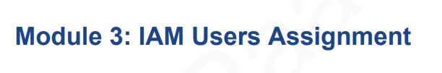

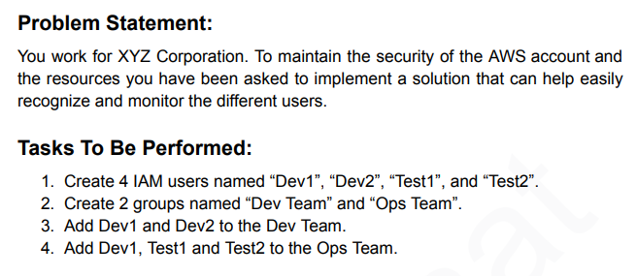

1. Creating 4 IAM Users So Need to go IAM Console > Users > Create User

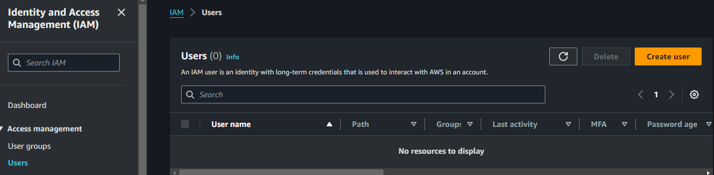

1. Select Name As per the Assignment and Provide Console Access and Select Custom or Autogenerated Password as your wish.

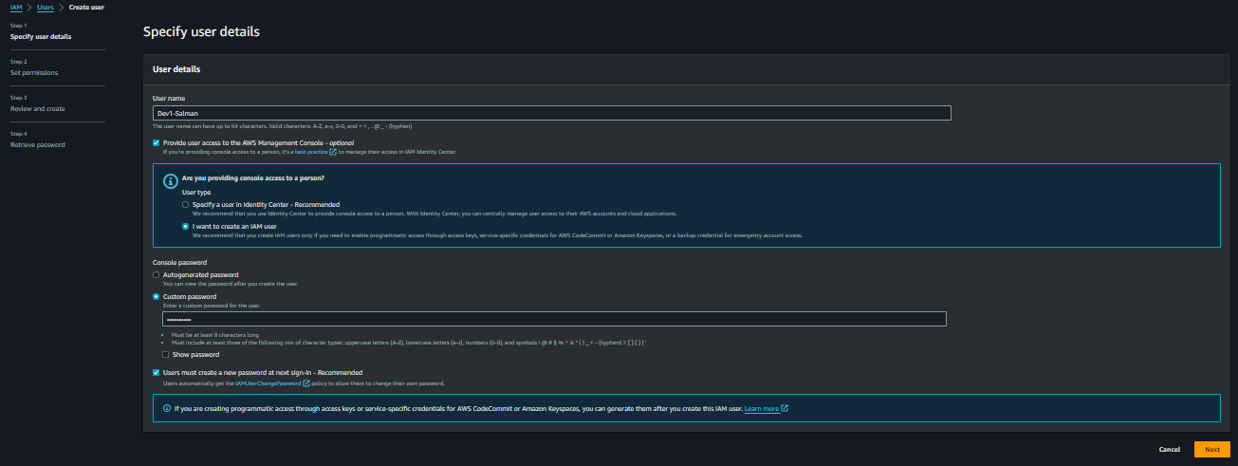

1. Add User to Group and Create Group From Here Or Click Next, later also can Add in Group

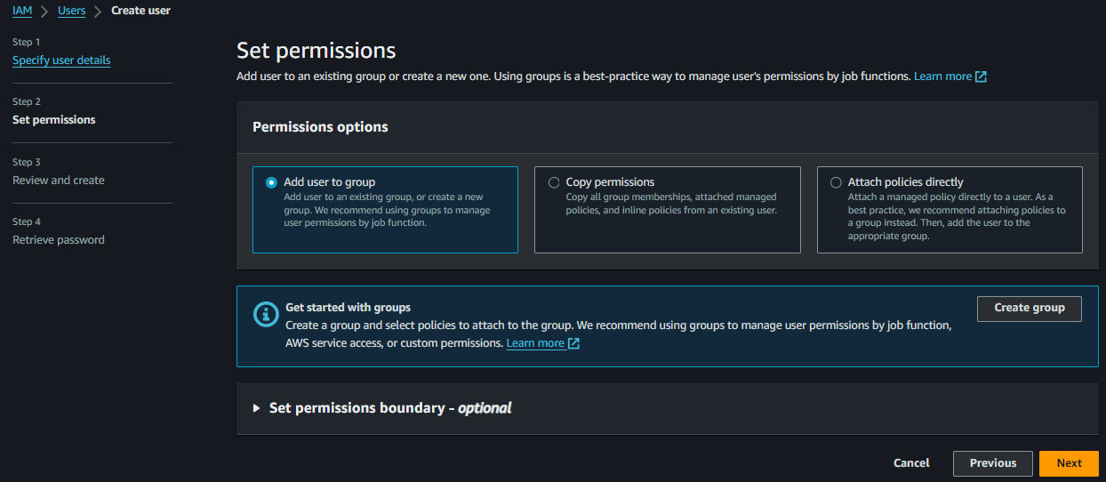

1. Created a Group As Per Assignment Dev-Team and Click Next

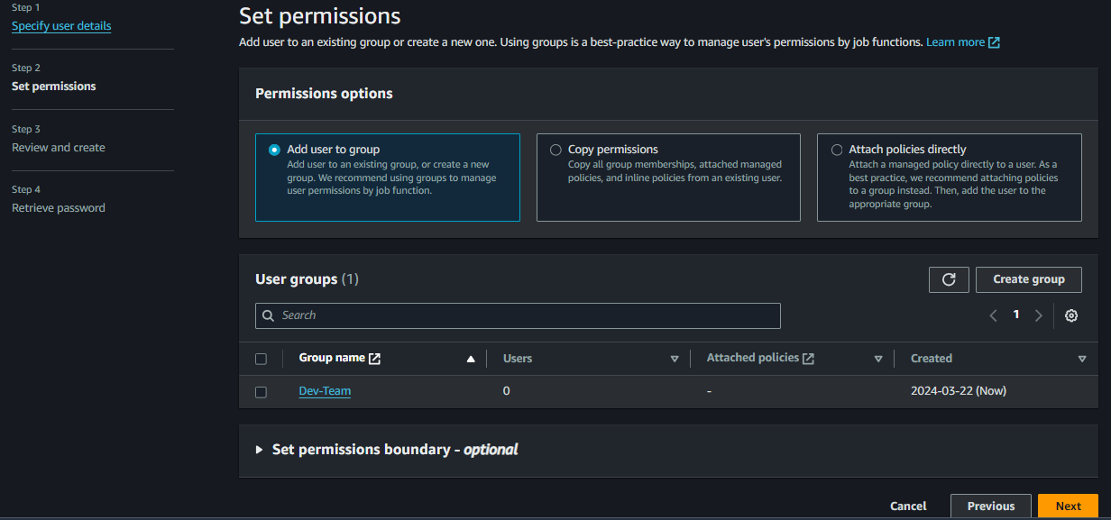

1. Review and Click Create User

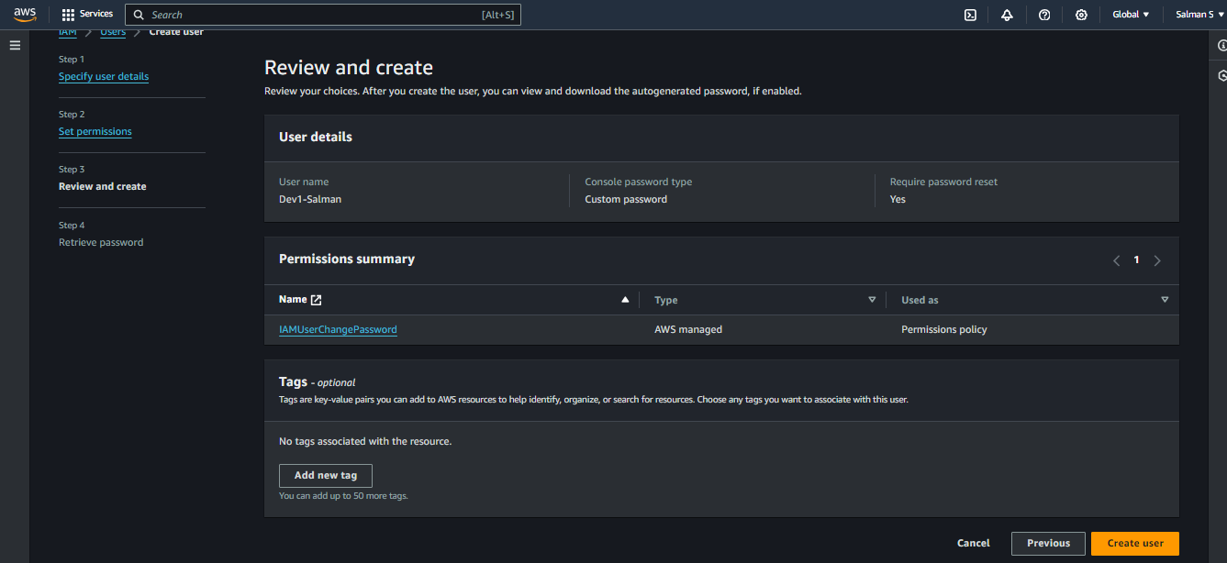

1. I Created Group while Creating Users

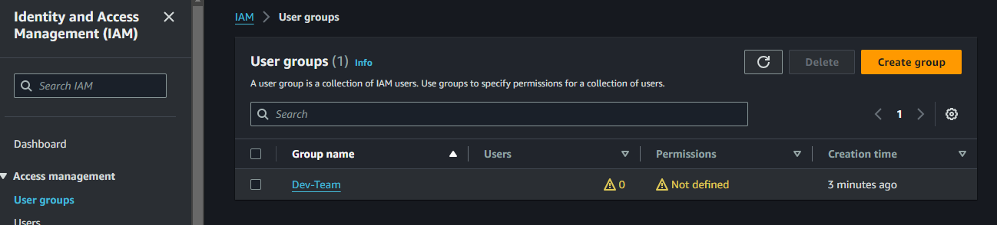

1. Click Dev-Team and Go Users > Add Users on right side end

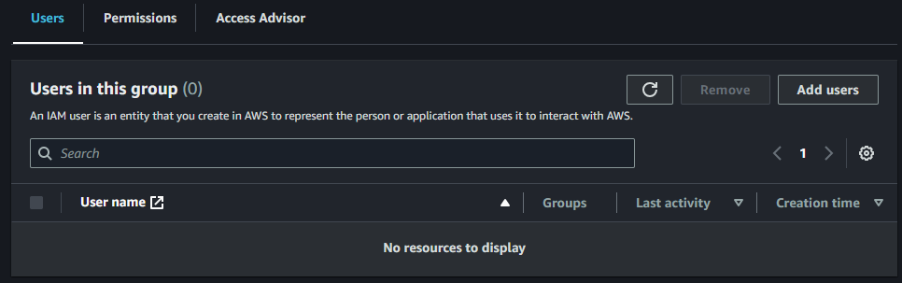

1. And Add Dev1-Salman in Dev-Team

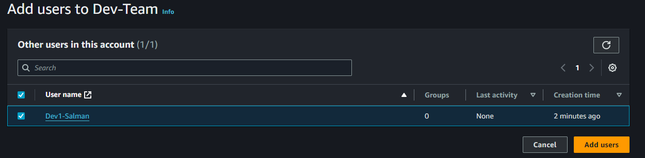

1. Create another 3 Users From Following Above the Steps and also Create Another Group

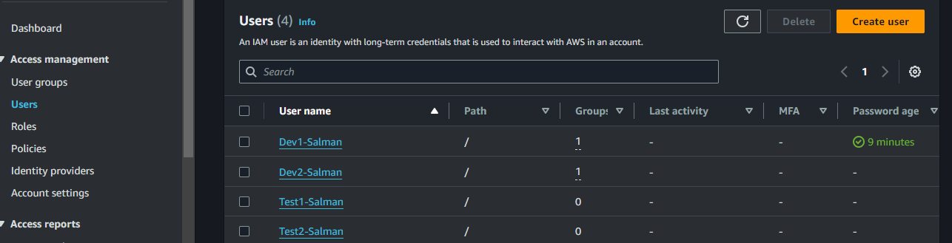

1. Add Dev2-Salman in Dev-Team

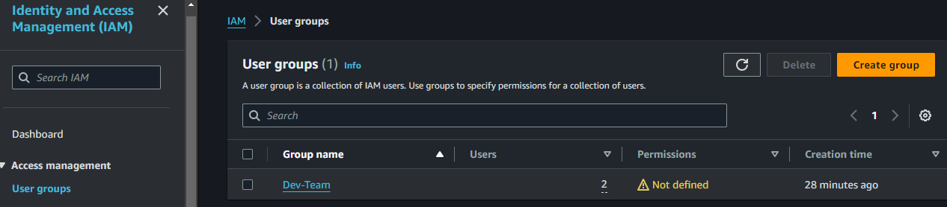

1. Now I’m Adding 3 Users in Ops-Team As per the Assignment

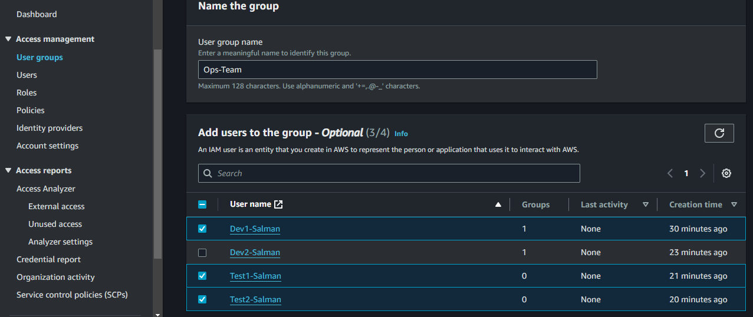

1. Now in the Dev-Team Having 2 Users and Ops-Team Having 3 users

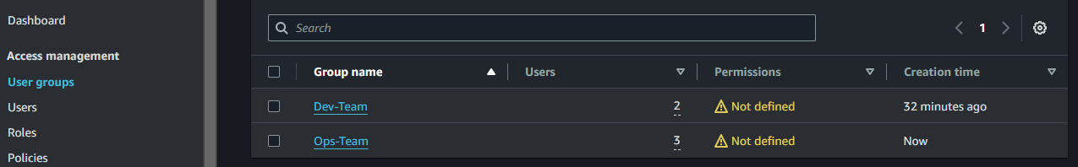

1. Now we can see As per the Assignment Dev1 in 2 Groups and This Dev-Team

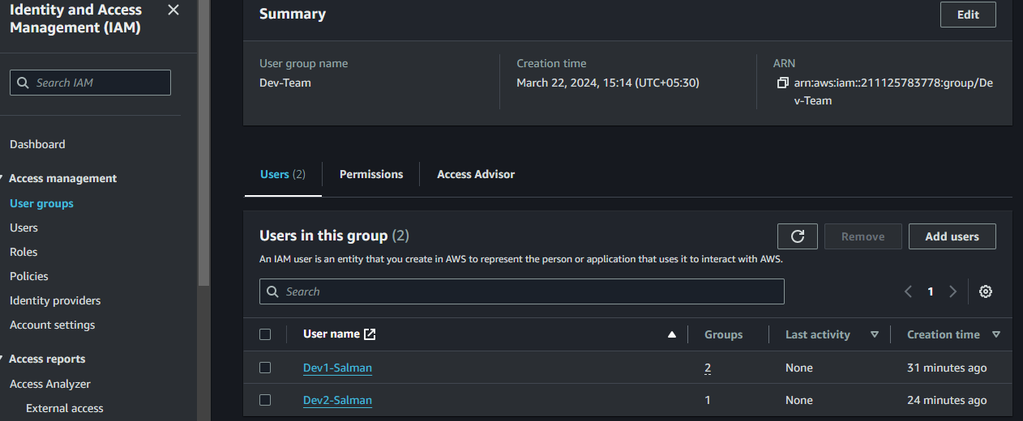

1. Now this is Ops-Team Creating and Adding the Users in Groups Successfully Completed

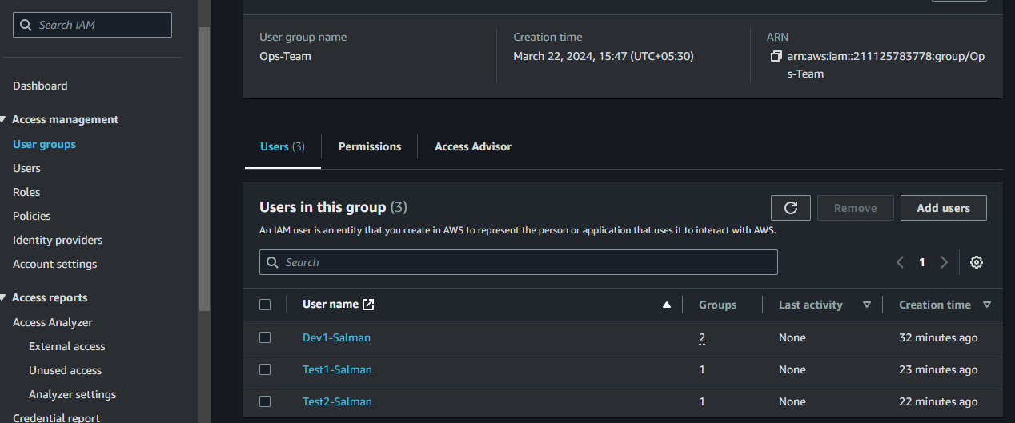

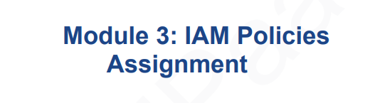

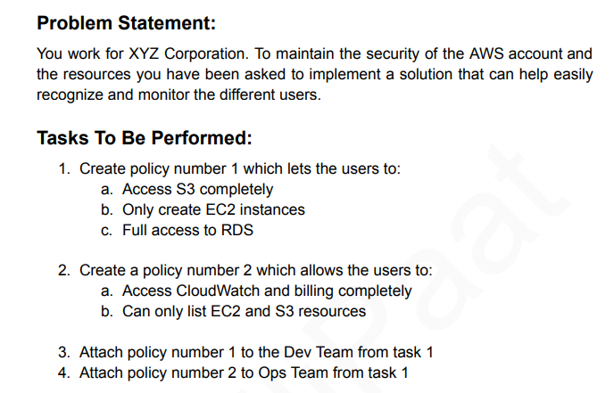

1. Now I am Loged in as Dev1-User Checking that have Permission to Use? Now we see No Permission

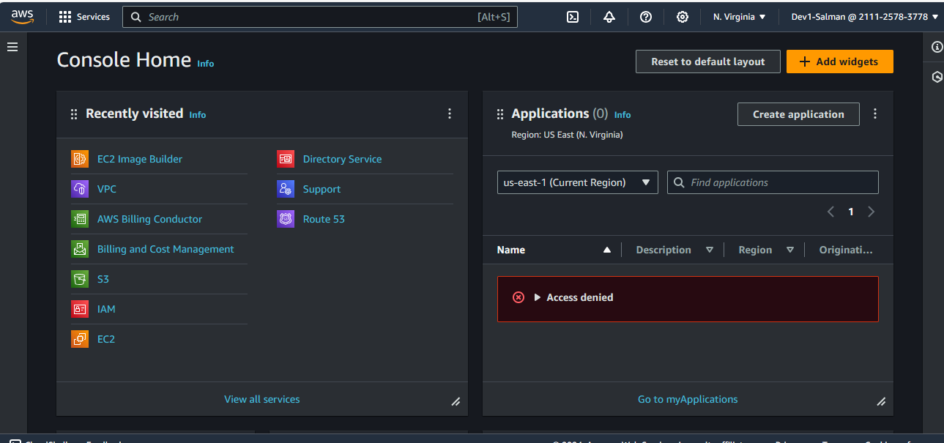

1. Now Assignment-2 Create Policies Go to IAM Dashboard > Polices > Create Policy

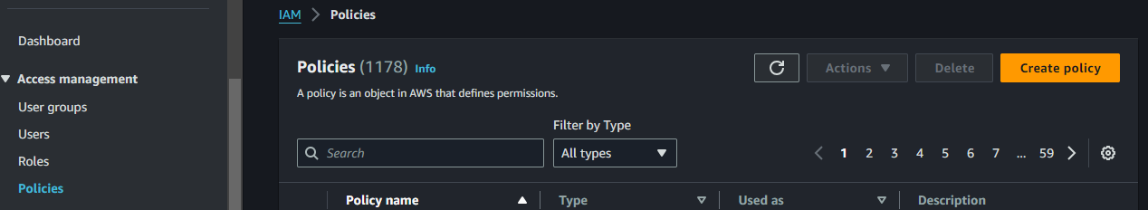

1. Now to Add Permissions using visual or Json and I am Using Json

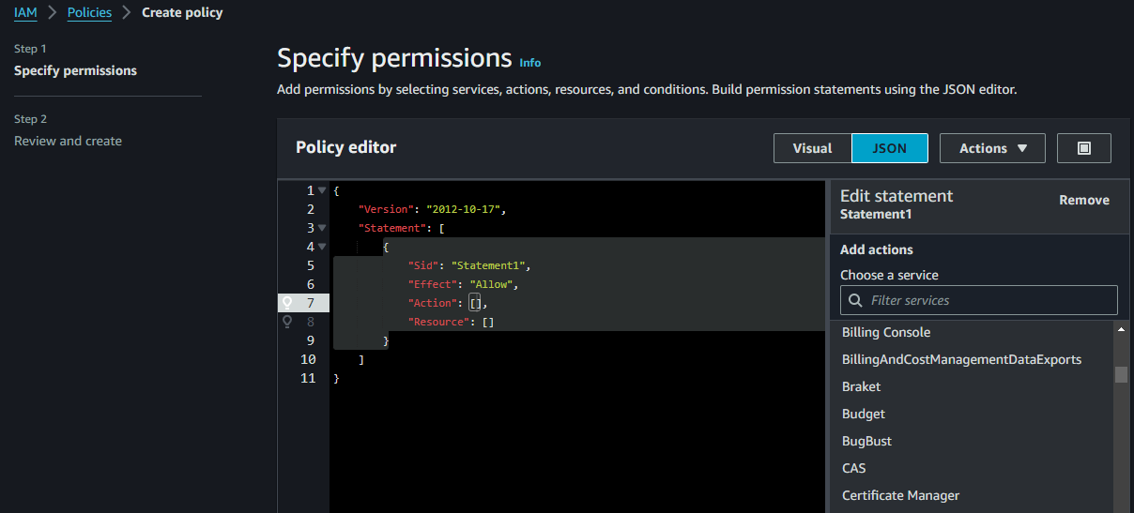

1. So In the Statement1, I Add s3 and Allow All Services for s3 and Click All Resources and Allow it

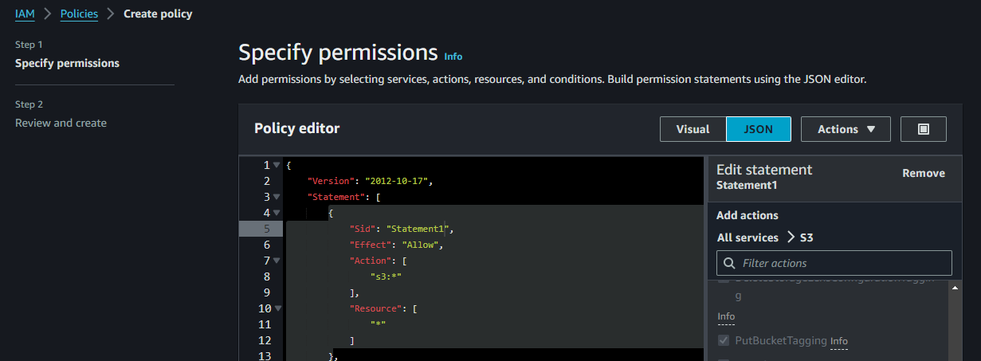

1. We can Add New statement and Add a Resource Option and Add a Condition Option too

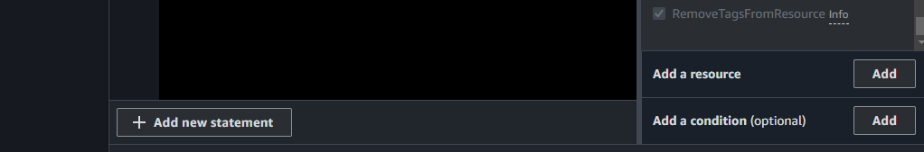

1. Added Statement2 and Allowed RDS All Services and Allowed All Resources

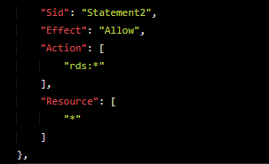

1. Adding Statement 3 only Allow to Create EC2 Instances EC2 but, find Below the Services which allowed to EC2 as per the task

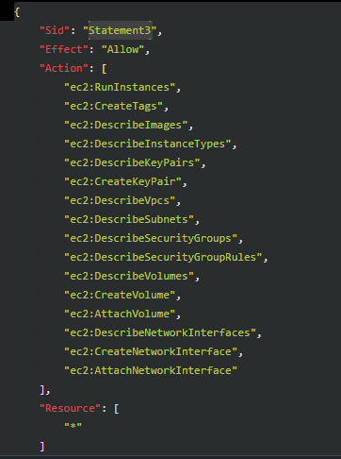

1. Give a Policy Name and Check your Permissions which defined to policy

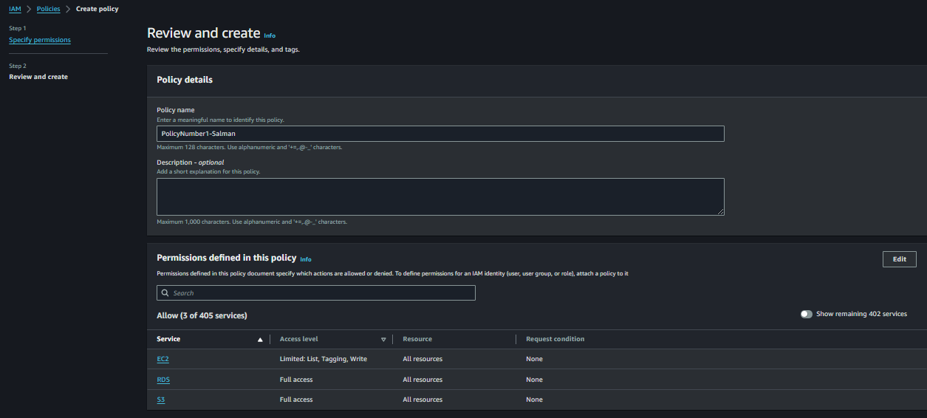

1. Now go to Groups Section and Go To Dev Team

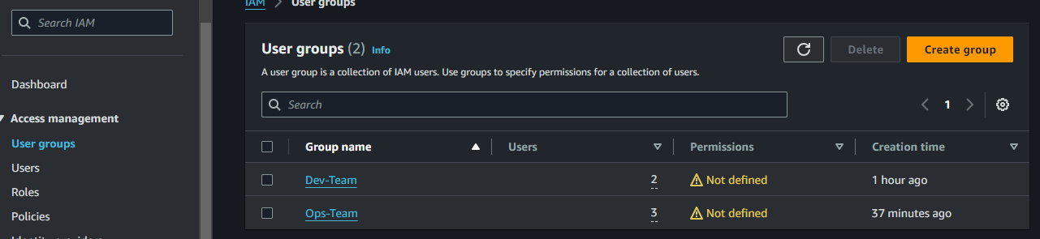

1. As per Task Click on Dev-Team > Permissions > Right Side Add Permissions > Attach Policies

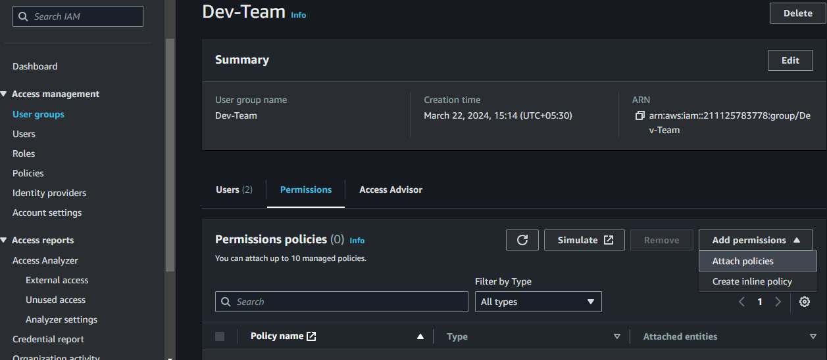

1. Select Your Created Policy and Attach Policies

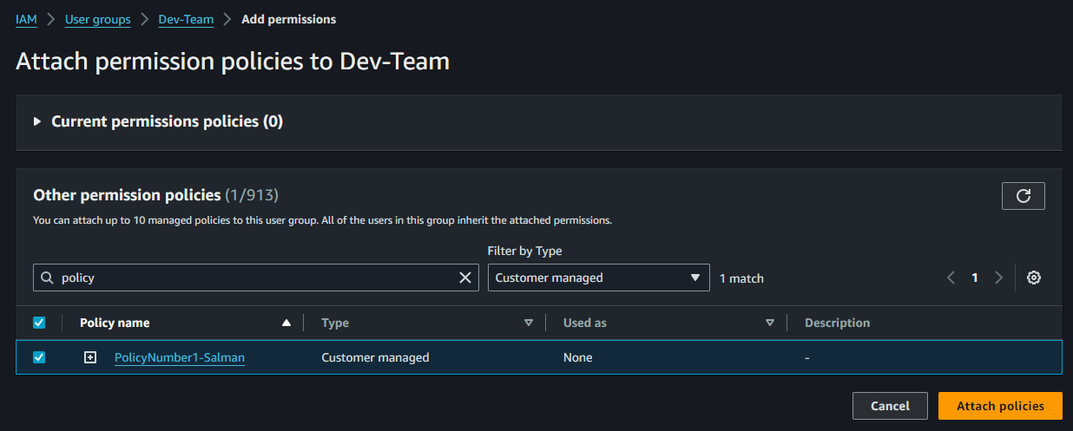

1. Now See that Permssions Defined

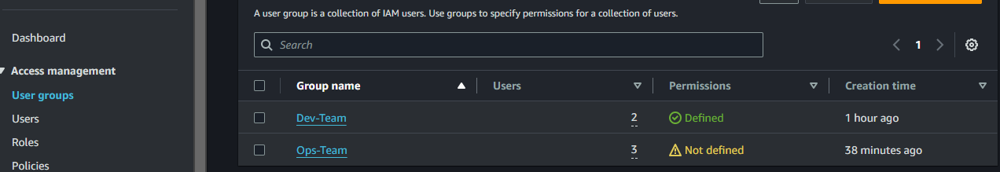

1. Now Check with Dev1-User use to see and edit s3 bucket because permission defined

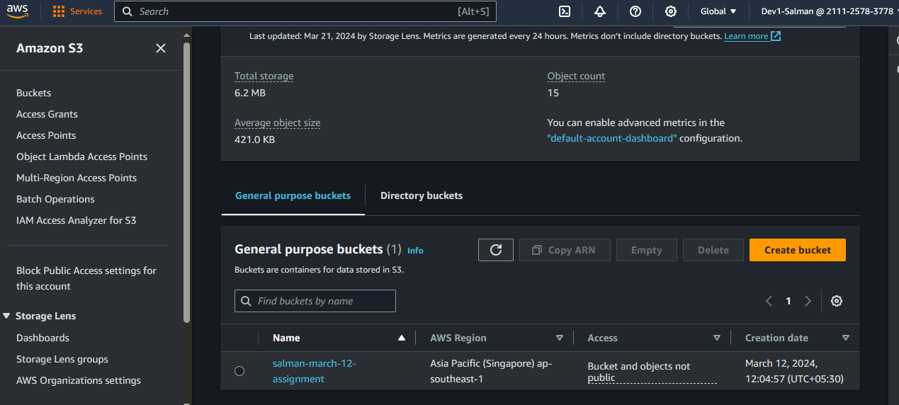

1. Now to go Polices and Create another Policies add Services as per the Task and Go Ahead

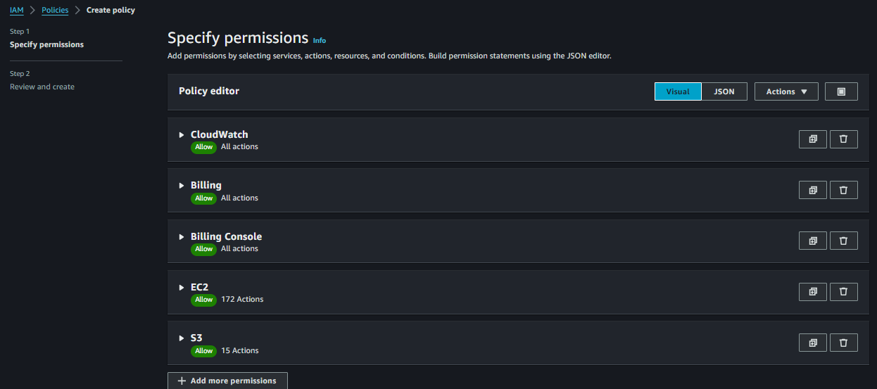

1. Triggered Error Because Non-Whitespace Character Limit of 6144

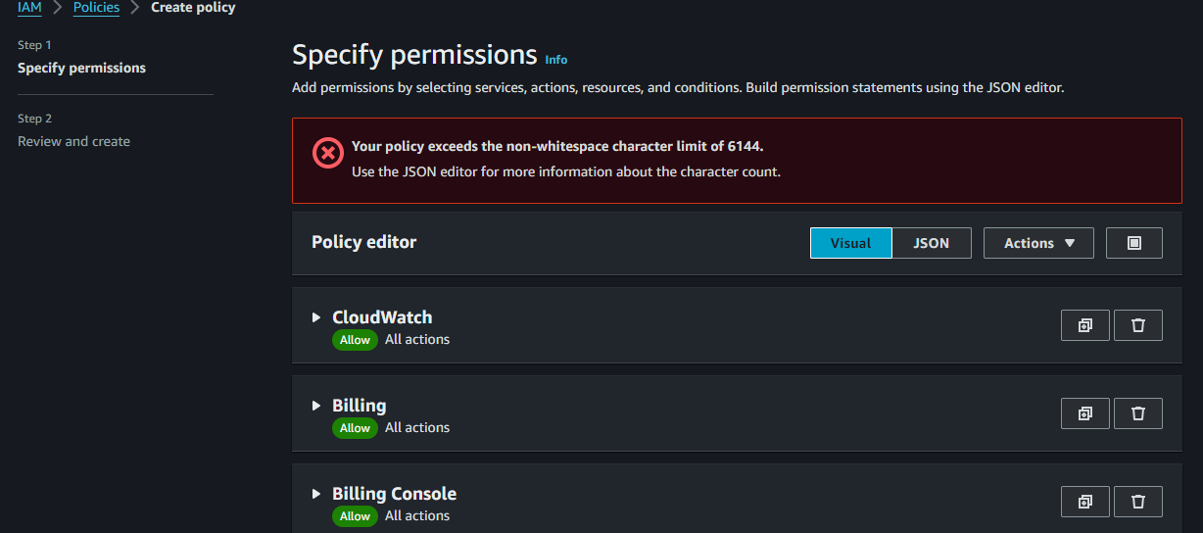

1. So Removed EC2 All Lists and Creating a Policy2a-Salman

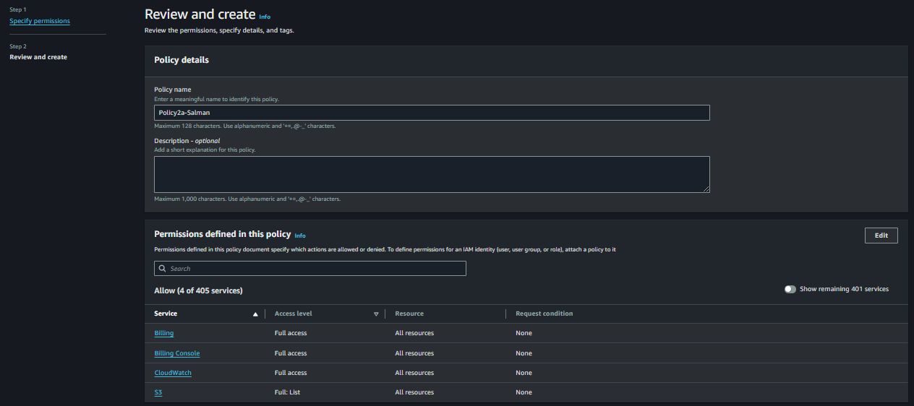

1. Now Again Creating Another Policies added EC2 All Lists and Click Next

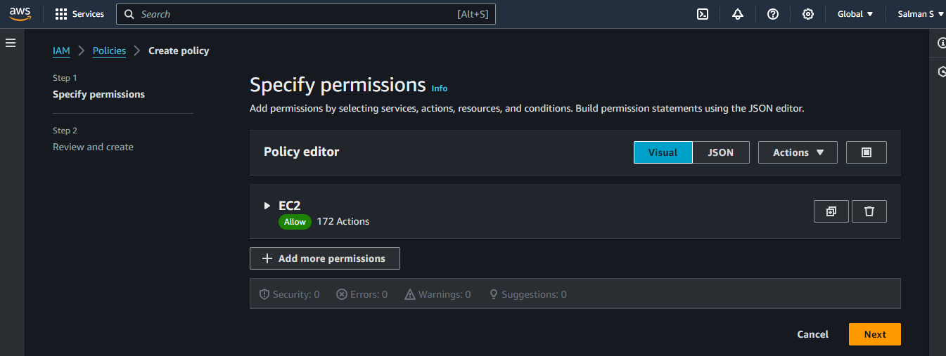

1. Policy2b-Salman

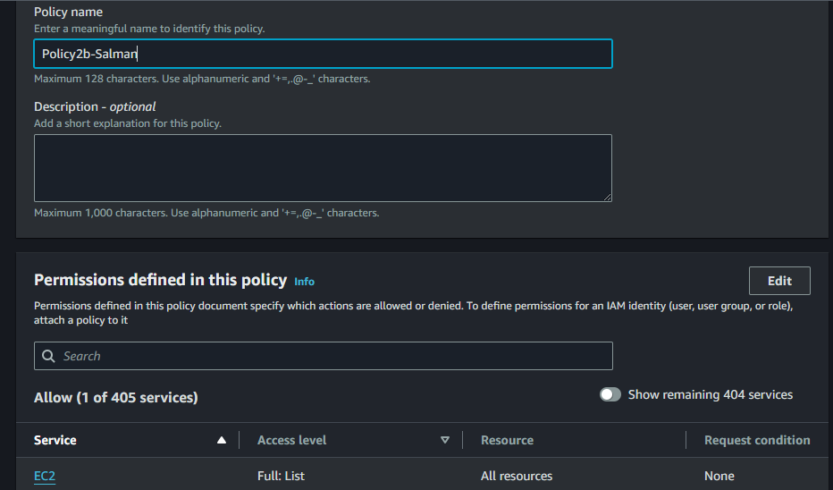

1. Now This Time go to Ops-Team As per the Task and Click

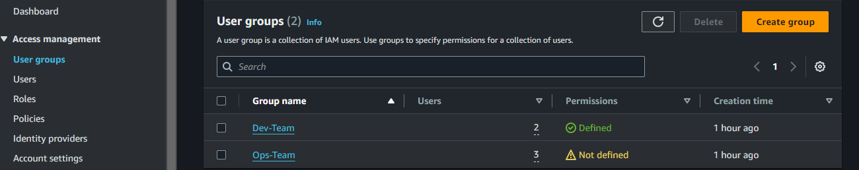

1. Same Click Attach Polices

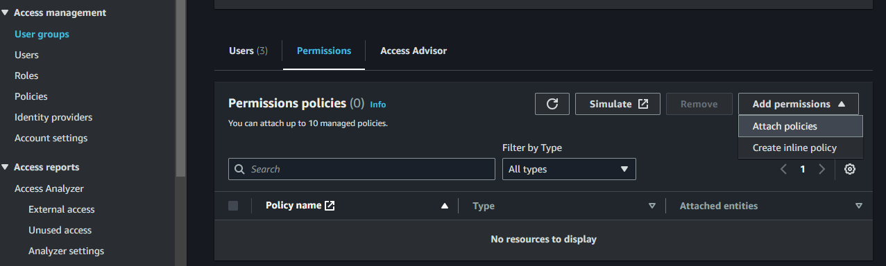

1. Select 2 policies which we created for Ops-Team and Attach it

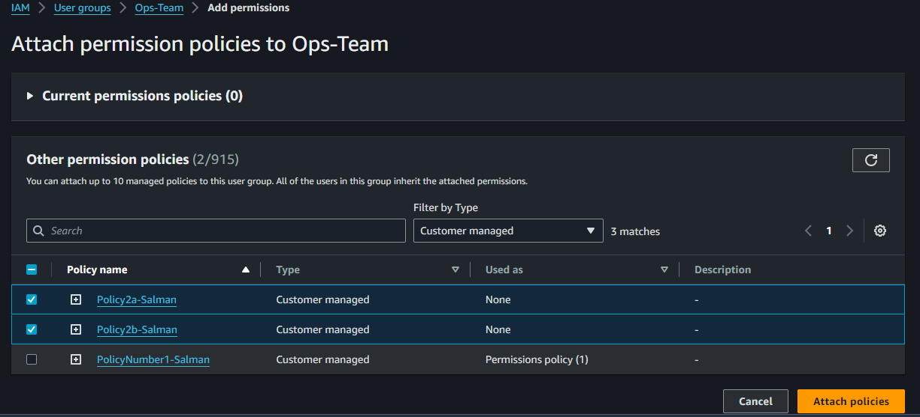

1. Now its Defined to Ops-Team and we Created Successfully Users and Policies

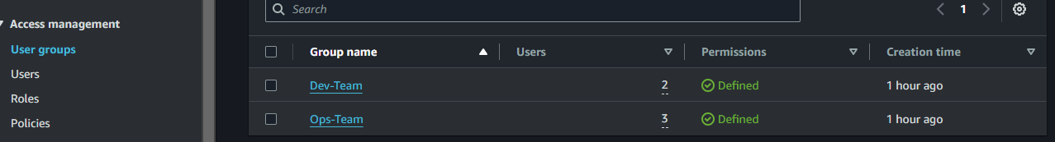

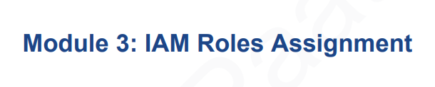

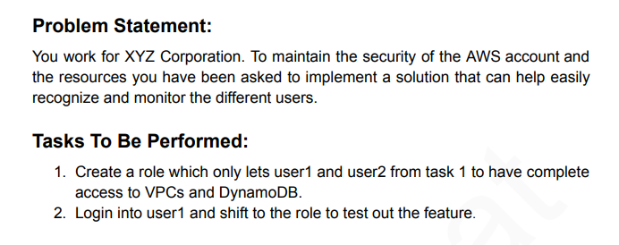

1. Go to IAM Dashboard > Roles > Create Role

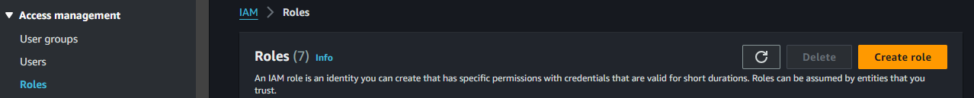

1. Select Custom Trust Policy and Go to Code > Principal

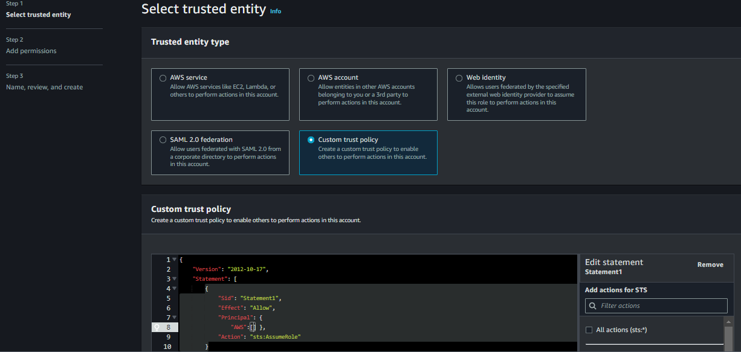

1. Go to Users Copy ARN of Dev1-Salman as User1 in the Task

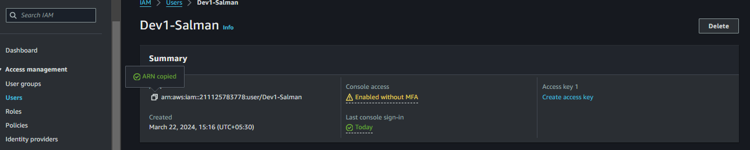

1. In the Principal part paste copied user1 ARN

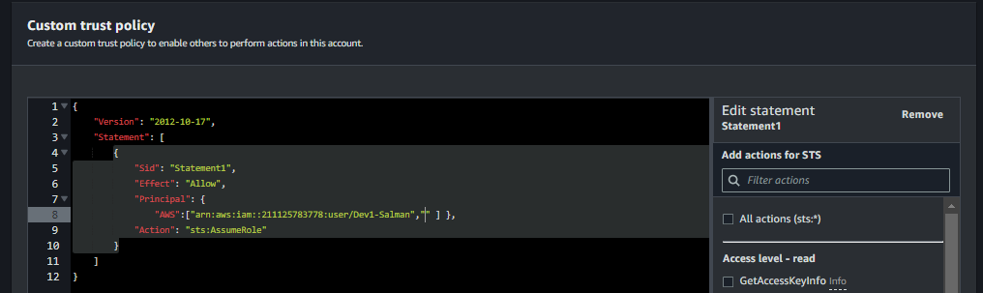

1. Go to User2 and Copy ARN

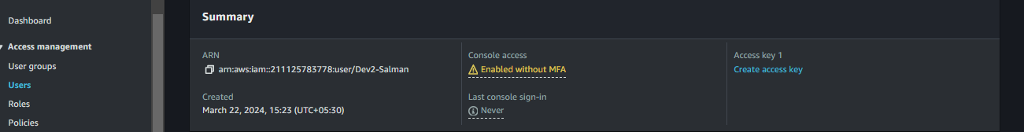

1. Again Come Paste Here

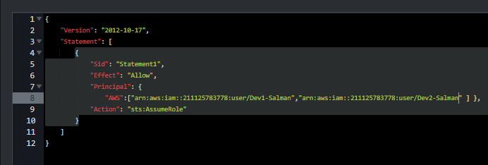

1. After Pasted the ARN and Clicking Next and finding Permissions Polices and Attach VPCfullAccess

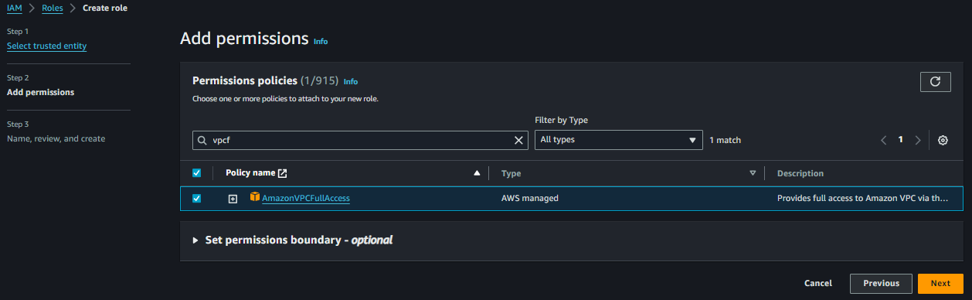

1. And Select Another Permission As per the Assignment DynamoDBFullAccess

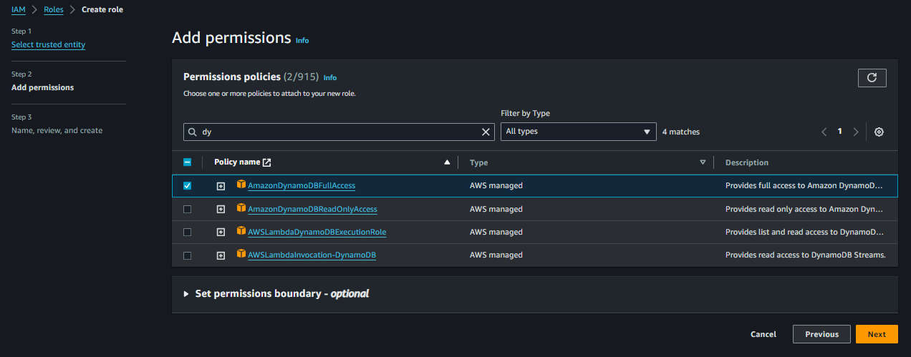

1. Name, Review and Create

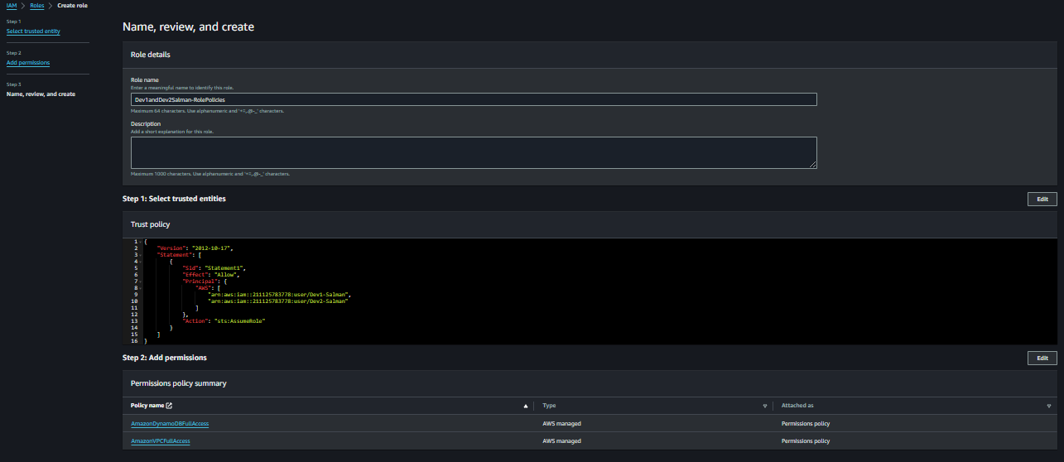

1. Created Role and Able to See the Code here and Also We can Edit it

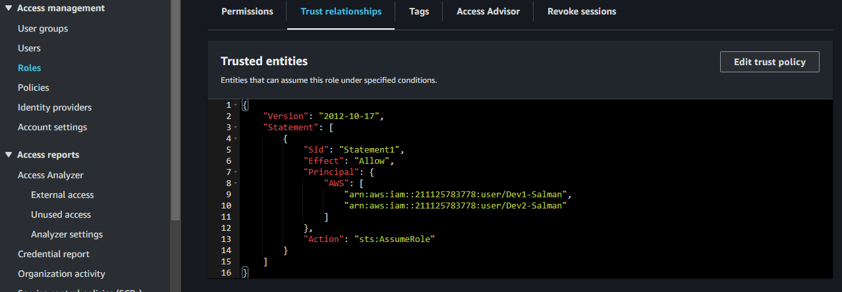

1. Check ones Login As a Dev1-Salman User able to Create DynomoDB Table see its saying your not authorized to create and Top Right Side Click on Account Id u will get a Option Switch role

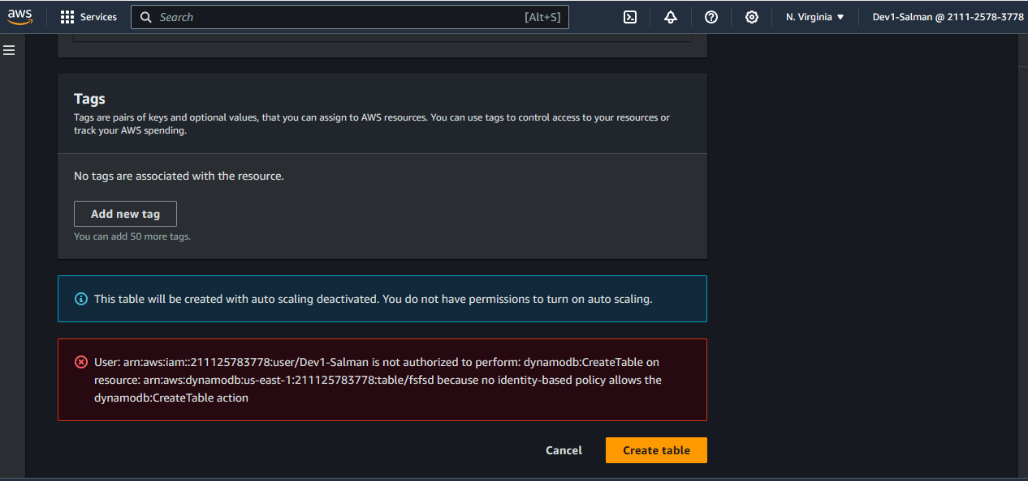

1. Paste the All Details and Role Name Which U Given and Login

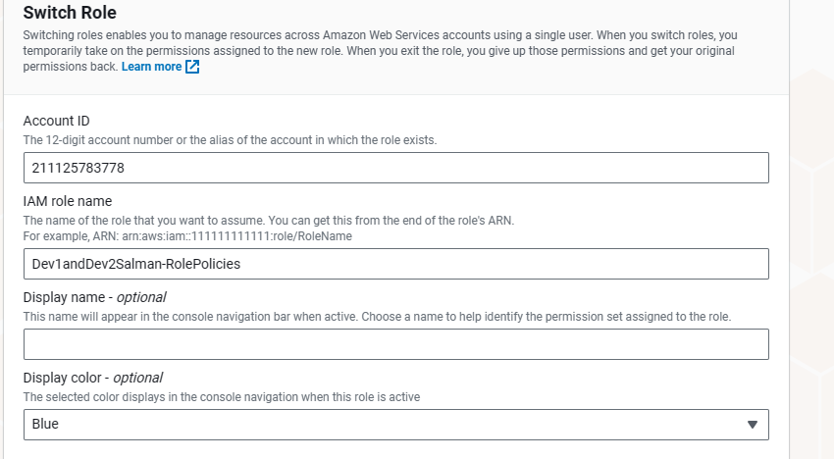

1. Now Logged as IAM-Role and See Now we able create table in Dynomodb

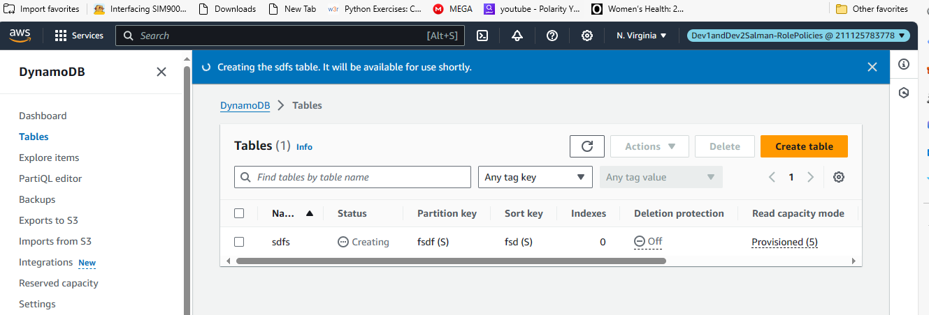

1. Previously As a IAM-User we Authorize to use s3 but not in IAM-Role

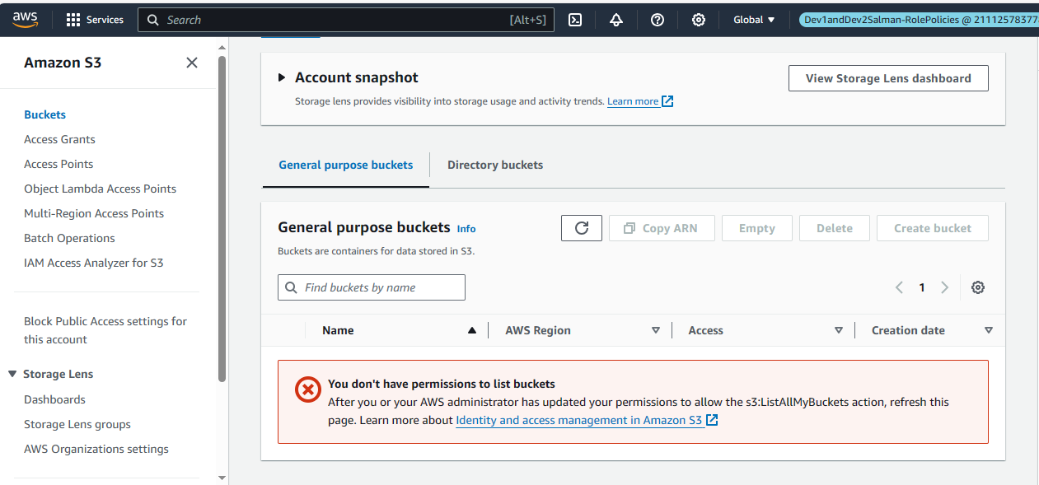

1. Switch Again IAM-User and Able and See and Create S3 bucket As a Dev1-user

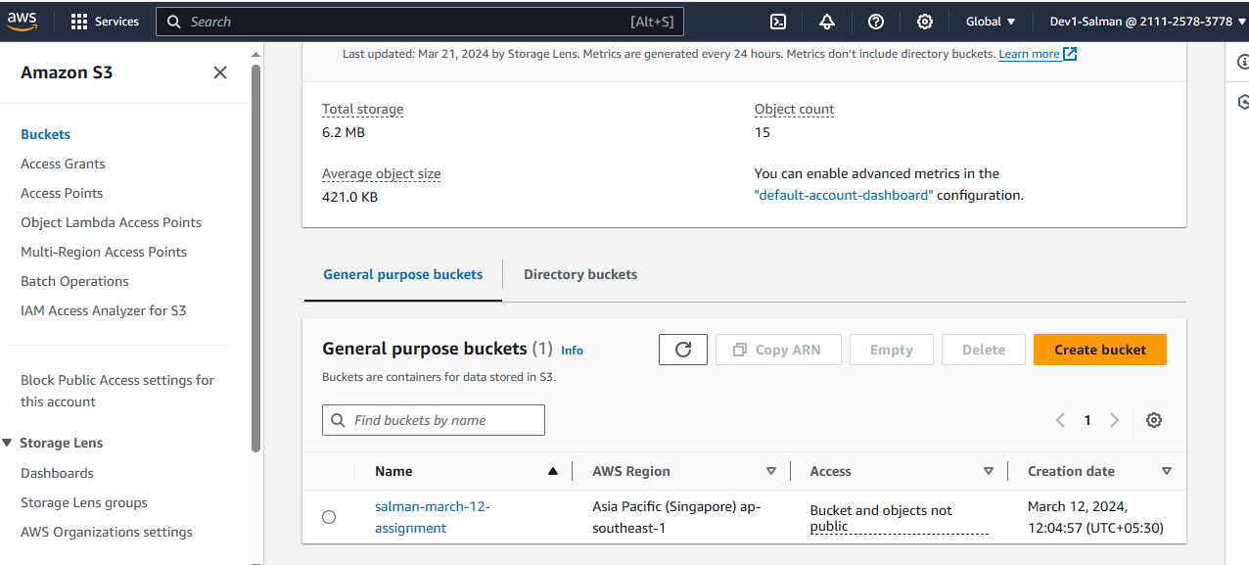

\*IAM-User :

IAM users represent individual users who can interact with AWS resources using their own long-term credentials (username and password, access keys, etc.),

\*IAM-Role :

while IAM roles are a way to delegate permissions to entities within or outside your AWS account, such as applications or AWS services. Roles are temporary and can be assumed by users, services, or resources, granting them specific permissions for a limited duration.